**IMPROVE LOYALTY, REFERRALS, PROMPT PAYMENT OF SCHOOL FEES & LEARNING OUTCOME**

**With Artificial Intelligent (AI) Powered Parent Loyalty Reward & Academic Performance Management System**

***…Use it to achieve 3 figure enrolments annually, double your business in 2 to 3 years and increase revenue…***

GET PARENT LOYALTY REWARD PLATFORM & ACADEMIC PEFORMANCE MANAGEMENT SYSTEM NOW FOR A LOW TERMLY FEE

* Smart Web-Based Cardless Parent Loyalty Creation Platform That You and Your Parent Can Access from Any Phone or Computer with Internet Access.
* Done For You’ Customer Loyalty and Learners’ Academic Performance Management Platform Included.
* Promoting Prompt Payment of School Fees, Motivating Existing Parents to Refer, Promoting Continuous Patronage and Discouraging Sudden Withdrawal of Parents.
* Customisation Ability Included - You Can Set Your Reward Amount, Add Logo, Add Banner and Your School Profile.
* Cutting Edge A.I. Powered Software Makes This a Simple Way to Make Money and Motivates Parents to Take Loyalty Actions with Cardless Loyalty Programs.
* Manage and generate metrics that improve learners’ academic performance.
* Step-By-Step Training Included - No Complicated Set up.
* This Is the Perfect Service to Offer Parents In 2022.
* No Technical Skills Needed or Sales Experience Needed.
* Get Started Today for A Low Termly Fee!

**Great Parents Love**

**LOYALTY PROGRAMS**

**Before We Dive In, We Want to Share a Story About Some Great Parents, Who Were the Inspiration for Nova Parent Loyalty System**

Great Parents love loyalty programs.

You might even go as far as to call these Parents ‘loyalty program junkies.’

When they open their wallet, they have got a loyalty card for just about every major department store you can imagine…

…and then they are also a member of various cardless loyalty programs that are offered by airlines, hotels, and various restaurants.

Not too long ago, Raymond received a delivery in the mail from an airline offering a loyalty program that would give him a free point for every time he flies with them.

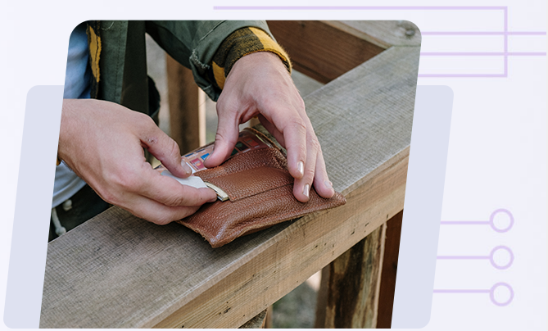

Of course, Raymond loved this idea, and he went to his child school to ask them if they could offer something similar.  
  
But his lifelong child school shocked him by saying, “NO. we would like to but it is not in our policy to do so and also the schools that offer such rewards charge an arm and a leg too, so you’re out of luck Raymond”  
  
**It wasn’t because they didn’t want to give Raymond a special deal…**  
  
They had wanted to offer a loyalty program for a LONG TIME, **but the costs and headaches for a small and medium size school to set up something like this make it almost impossible.**





And of course, tracking everything manually is just too much work for a medium and small size school owner…

Raymond asked several other local schools why they don’t have a loyalty program…

…and EVERY school he talked to wanted one because they KNOW it will bring them more enrolment, improve school fees collection, reduce loss of parents and they see the big schools using these programs with a lot of success…

But it’s just time consuming, expensive, and complicated for the little guy to set it all up…

So, We Made It Our MISSION At the School Support Centre to Help All sizes of Private Schools to Create Cardless Loyalty Reward Programs…

Due To the Pandemic, Businesses **All Over the World Are**

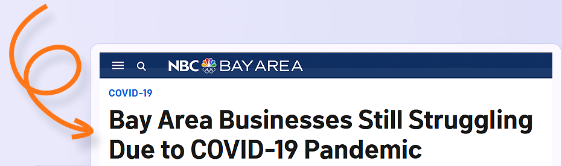STRUGGLING MORE  
THAN EVER BEFORE…

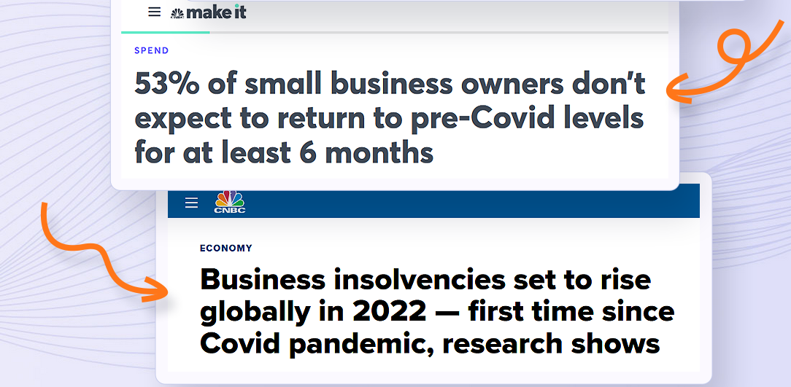

**But Did You Know That More  
Millionaires Are Made in Bad Economies?**



If You Can Motivate Your Parents to Get You Enrolments, Pay Their Children School Fees Earlier, Stay and Abide with You…

…IT’S A MASSIVE OPPORTUNITY **For You to Make a Lot of Money**



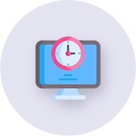

**Traditional Online Methods Take Time to Start Working** or Have High Start-Up Costs

Many Marketing Methods  
For Schools Are  
**Hard to Measure**

Schools Have Tried Just About Everything and **They Are STILL Struggling**

**Again, Do You Know? …**

**USING EXISTING CUSTOMERS To Refer New Enrolment To Your School Is A Lot More Effective  
Than Finding New Customers**

**We’ve Got a Powerful Method for Helping Schools Grow Enrolment Boost Revenue & Maximize Profits**From Their Existing Customer Base…

**Here’s Why Private Schools LOVE This…**

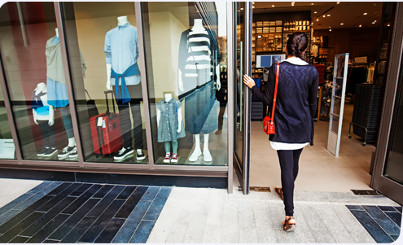

**Parents are Motivated to Refer Enrolment and Add** Additional Child from their Family



**They Are Motivated to Pay Their Children School Fees Early**



**Because There Is Not an Additional Cost to Acquire a New Enrolment,**

The Profit Margins for The School Are MUCH Higher Than Other Customer-Attraction Methods

**We’re Able to Do This  
With Our New Software That Creates**

CARDLESS LOYALTY REWARD PROGRAMS & GENERATE METRICS THAT IMPROVE LEARNING OUTCOME WITH A FEW CLICKS

**Statistics Prove That**

**Loyalty Programs Are a Great Way To**

BOOST ENROLMENT FAST

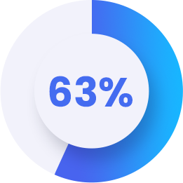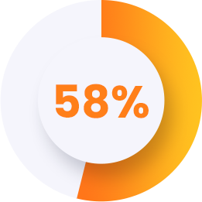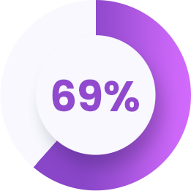

**Will Not Commit to A Brand That Does Not Offer Loyalty Benefits**

**Of Consumers Shop at Stores Whose Loyalty Programs They’ve Joined** At Least Twice Per Month

**Of Customers Allow the Presence of Rewards or Loyalty Programs** to Influence Their Shopping Decisions

**The School Support Centre Creates Cardless Loyalty Reward Programs**

WITHOUT ANY TECHNICAL  
SKILLS REQUIRED

This Is What Your School Is Going to Be Like When You Start Offering Parents Cardless Loyalty Reward Programs…



**You Make the Smart Decision to Subscribe to Nova Parent Loyalty Reward System at A Discount**

(And It’s One of The Best Things You’ve Ever Done Because It’s Simple, It Works, And It’s Actually helping Out Schools) …



**You’ve Just Landed Your 5th Enrolment Without Any Hard Selling Required,**

And It Looks Like You’ve Got More Children That Will Enrol This Week…



**Your Parents LOVE You Because You’re Helping Them Win Rewards**

For Being Responsible to Their Obligations Towards Their Children Education Needs…

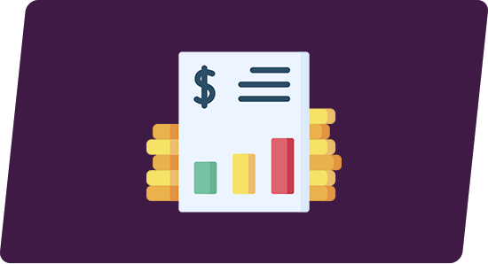

**We Can Prove That What the Parent Loyalty Reward Platform Is Doing for You**

Works Because Of The Built-In Performance Tracking Analytics…



**You’re Currently Achieving More Enrolment, Prompt Payment of School Fees and Fewer Loss of Parents**

And Your Revenue Just Keeps Increasing…



**You’re Helping Parent Takes on Positive Attitude That Promotes Their Children Education**

AND You’re Able to Do All This in Just A Few Minutes Per Day Because the Parent Loyalty Reward Platform Makes This Simple…

**Are You Ready to Make This a Reality  
And Create a Life-Changing**

RECURRING INCOME STREAM WITH  
CARDLESS LOYALTY PROGRAMS?



GET PARENT LOYALTY REWARD PLATFORM & ACADEMIC PEFORMANCE MANAGEMENT SYSTEM NOW FOR A LOW TERMLY FEE

PRICE: ~~N99, 950.00~~ SAVE 50.01% N49,950.00 per term